Linux Programming: Assignment-6:

- Which command is used to list the contents of a directory? Justify with proper example.

- Write the command to create a new directory named 123test_dir.

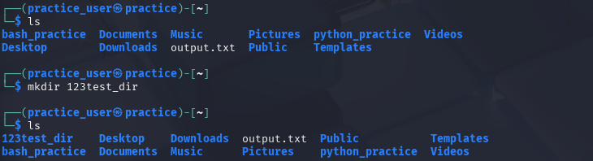

- What is the purpose of the sed command? Justify with proper example.
- “sed” is used to quickly modify text from the command line without manually opening files.
- It can find, replace, insert, delete, or modify text in files or input streams without opening the file in an editor.
- NOTE: “s/” means substitute.
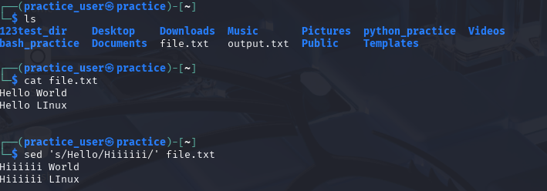
- Which distinct command is used to display one-line descriptions of any commands?
- whatis command is used to display one line descriptions of any commands.
e.g.) whatis ls
#OUTPUT : ls (1) - list directory contents

- Write the command to create an empty file named “notes.txt”.
- touch command
e.g.) touch notes.txt #creates an empty file called notes.txt

- Differentiate between grep and awk commands with an example.
- “grep” is mainly used for searching specific text or patterns in a file.
e.g.) as you can see down, it only prints the lines which includes “ERROR”.

- awk is more powerful — it can search, filter, and process data (like printing specific columns, doing calculations, etc.).
e.g.) as you can see down, it only prints 2nd , 3rd & 4th columns from each line.

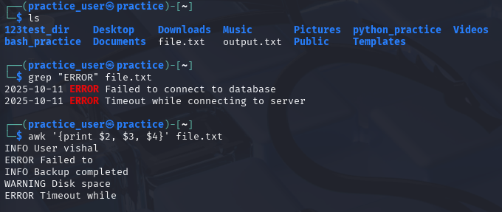

- Write the command to give read, write, and execute permission to the owner of a file script.sh.
- This gives,
- owner to read, write & execute permissions (4+2+1)
- Group to read permissions(4+0+0)
- Others to read permissions(4+0+0)
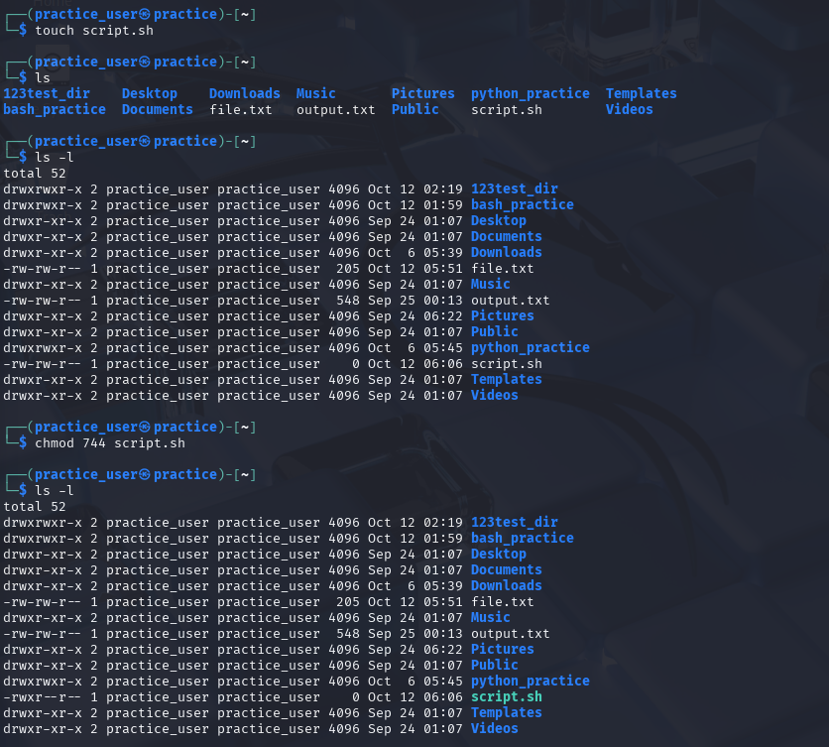

- How is chown different from chgrp? Give one example for each.
- chown and chgrp are both used to change ownership information of files, but they do it in slightly different ways.

- The “chown” command changes the owner of a file or directory. Every file in Linux has an owner usually the person who created it. Sometimes, you may want to transfer that ownership to another user & this is where it’s used.
e.g.) sudo chown vishal notes.txt
# This means that the user vishal now becomes the owner of the file notes.txt.

- The “chgrp” command, on the other hand, changes the group associated with a file. Groups in Linux are used to manage permissions for multiple users at once.

For example, a project group where all members should read or edit certain files.

e.g.) sudo chgrp staff notes.txt

# This changes the group ownership of the file notes.txt to the group “staff”, meaning all members of that group will now have the permissions set on the file.

- A user complains that they cannot execute a file even though it exists in their directory. How would you troubleshoot this using ls -l, chmod, and whoami?
- First I would use “ls -l filename” command to see the permissions of that file and I would look for executable(x) permissions in that file if they are missing or not.
If it is so, it’s the most likely reason that the user is not able to execute it .

- Then, I would use “whoami” command to see that I am logged in as whowm.
And I would compare it with the file’s owner as, if I’m not the owner or I don’t belong to the group that has execute rights, I won’t be able to run the file.
- And finally if I lie in the required permission zone(or using sudo), I would change the file permissions using “chmod +x filename”.

- Design a command pipeline to: find all .log files modified in the last 2 days in /var/log, display them on screen, and save the results into a file recent_logs.txt using tee command.

- cd /var/log | find -type f name “*.log” -mtime -2 | tee recent_logs.txt

